Kazımov Anar_Statistika

- State whether each of the following variables is categorical or quantitative and indicate its measurement scale.

a. Annual sales
b. Soft drink size (small, medium, large)
c. Employee classification (GS1 through GS18)
d. Earnings per share
e. Method of payment (cash, check, credit card)
2) These data show the time in days required to complete year-end audits for a sample of 20 clients of Sanderson and Clifford, a small public accounting firm.
Construct a relative frequency and percent frequency distribution table for these data.
3) In San Francisco, 30% of workers take public transportation daily.
a. In a sample of 10 workers, what is the probability that exactly three workers take public transportation daily?
b. In a sample of 10 workers, what is the probability that at least three workers take public transportation daily?

4) In January 2003, the American worker spent an average of 77 hours logged on to the Internet while at work (CNBC, March 15, 2003). Assume the population mean is 77 hours, the times are normally distributed, and that the standard deviation is 20 hours.
What is the probability that in January 2003 a randomly selected worker spent fewer than 50 hours logged on to the Internet?
5) Which meal are people most likely to order at a drive through? A survey was conducted in 2009, but the sample sizes were not reported. Suppose the results, based on a sample of 100 males and 100 females, were as follows:

If a respondent is selected at random, what is the probability that he or she prefers ordering lunch at the drive-through?
6) The Consumer Reports National Research Center conducted a telephone survey of 2000 adults to learn about the major economic concerns for the future (Consumer Reports, January 2009). The survey results showed that 1760 of the respondents think the future health of Social Security is a major economic concern.
a. What is the point estimate of the population proportion of adults who think the future health of Social Security is a major economic concern.
b. At 90% confidence, what is the margin of error?
c. Develop a 90% confidence interval for the population proportion of adults who think the future health of Social Security is a major economic concern.

- A doctor’s office staff studied the waiting times for patients who arrive at the office with a request for emergency service. The following data with waiting times in minutes were collected over a one-month period.
2 5 10 12 4 4 5 17 11 8 9 8 12 21 6 8 7 13 18 3

Use classes of 0–4, 5–9, and so on in the following:
a. Show the frequency distribution.
b. Show the relative frequency distribution.
c. Show the cumulative frequency distribution.
8) A population of 2 liter bottles of cola is known to have a mean fill-weight of 2.06 liters and a standard deviation of 0.02 liters. The population is known to be bell-shaped. Using the empirical rule, describe the distribution of fill-weights. Is it very likely that a bottle will contain less than 2 liters of cola?
9) The driving distance for the top 100 golfers on the PGA tour is between 284.7 and 310.6 yards (Golfweek, March 29, 2003). Assume that the driving distance for these golfers is uniformly distributed over this interval.
a. Give a mathematical expression for the probability density function of driving distance.
b. What is the probability the driving distance for one of these golfers is less than 290 yards?
10) The time needed to complete a final examination in a particular college course is normally distributed with a mean of 80 minutes and a standard deviation of 10 minutes. Answer the following questions.
What is the probability that a student will complete the exam in more than 60 minutes but less than 75 minutes?
11) A sample of 500 respondents in a large metropolitan area was selected to study consumer behavior, with the following results:
Suppose that the respondent chosen is a female. What is the probability that she enjoys shopping for clothing?
- A paper manufacturer has a production process that operates continuously throughout an entire production shift. The paper is expected to have a mean length of 11 inches, and the standard deviation of the length is 0.02 inch. At periodic intervals, a sample is selected to determine whether the mean paper length is still equal to 11 inches or whether something has gone wrong in the production process to change the length of the paper produced.You select arandom sample of 100 sheets, and the mean paper length is 10.998 inches. Construct a 95% confidence interval estimate for the population mean paper length.

A bowler’s scores for six games were 182, 168, 184, 190, 170, and 174. Using these data as a sample, compute coefficient of variation.
- Suppose that the rate of return for a particular stock during the past two years was 10% and 30%. Compute the geometric rate of return per year. (Note: A rate of return of 10% is recorded as 0.10, and a rate of return of 30% is recorded as 0.30.)
- The following table provides a probability distribution for the random variable x.
a. Compute E(x), the expected value of x.
b. Compute the variance of x.
c. Compute σ, the standard deviation of x.
d. What is the probability that it takes at least 2 sessions to gain the patient’s trust?
- Axline Computers manufactures personal computers at two plants, one in Texas and the other in Hawaii. The Texas plant has 40 employees; the Hawaii plant has 20. A random sample of 10 employees is to be asked to fill out a benefits questionnaire.
a. What is the probability that none of the employees in the sample work at the plant in Hawaii?
b. What is the probability that one of the employees in the sample works at the plant in Hawaii?
16) A sample of 500 respondents in a large metropolitan area was selected to study consumer behavior. Among the questions asked was “Do you enjoy shopping for clothing?”Of 240 males, 136 answered yes. Of 260 females, 224 answered yes. Construct a contingency table to evaluate the probabilities. What is the probability that a respondent chosen at random is a female and enjoys shopping for clothing?
6) A simple random sample of 400 individuals provides 100 Yes responses.
a. What is the point estimate of the proportion of the population that would provide Yes responses?
b. Compute the 95% confidence interval for the population proportion.
17)Car rental rates per day for a sample of seven Eastern U.S. cities are as follows:
Compute mean, variance and standard deviation.
- Suppose that the rate of return for a particular stock during the past two years was -20% and 30%. Compute the geometric rate of return per year.
19) An average of 15 aircraft accidents occur each year
a. Compute the mean number of aircraft accidents per month.
b. Compute the probability of no accidents during a month
c. Compute the probability of exactly one accident during a month.
d. Compute the probability of more than one accident during a month.

20)You are trying to develop a strategy for investing in two different stocks. The anticipated annual return for a $1,000 investment in each stock under four different economic conditions has the following probability distribution:

Compute the
a. expected return for stock X and for stock Y.
b. standard deviation for stock X and for stock Y.

21)In an effort to estimate the mean amount spent per customer for dinner at a major Atlanta restaurant, data were collected for a sample of 49 customers. Assume a population standard deviation of $5.
a. At 95% confidence, what is the margin of error?
b. If the sample mean is $24.80, what is the 95% confidence interval for the population mean?

22)Let X be time in seconds spent on video downloading from OurCampus! web site. X has a mean of 7 seconds and a standard deviation 2 seconds. What is the probability that video download time for the OurCampus! website will be between 5 and 9 seconds.

23)The high costs in the California real estate market have caused families who cannot afford to buy bigger homes to consider backyard sheds as an alternative form of housing expansion. Many are using the backyard structures for home offices, art studios, and hobby areas as well as for additional storage. The mean price of a customized wooden, shingled backyard structure is $3100 (Newsweek, September 29, 2003). Assume that the standard deviation is $1200.

What is the z-score for a backyard structure costing $2300?

- A department of transportation’s study on driving speed and miles per gallon for midsize automobiles resulted in the following data:

Speed (Miles per Hour) 30 50 40 55
Miles per Gallon 28 25 25 23

Compute and interpret the sample correlation coefficient.

25) The time required to pass through security screening at the airport can be annoying to travelers. The mean wait time during peak periods at Cincinnati/Northern Kentucky International Airport is 12.1 minutes. Assume the time to pass through security screening follows an exponential distribution.
a. What is the probability it will take less than 10 minutes to pass through security screening during a peak period?
b. What is the probability it will take more than 20 minutes to pass through security screening during a peak period?

26)Sales personnel for Skillings Distributors submit weekly reports listing the customer contacts made during the week. A sample of 65 weekly reports showed a sample mean of 19.5 customer contacts per week. The sample standard deviation was 5.2. Provide 90% and 95% confidence intervals for the population mean number of weekly customer contacts for the sales personnel.

27)Consider the following hypothesis test:
A sample of 65 is used. Use α = .05 and make the conclusion.

28)Explain the non probability sampling methods. Give examples.

29)Consider a population of 1,024 mutual funds that primarily invest in large companies. You have determined that the mean one-year total percentage return achieved by all the funds, is 8.20 and that the standard deviation, is 2.75. According to the empirical rule, what percentage of these funds are expected to be within standard deviation of the mean?

- Small cars get better gas mileage, but they are not as safe as bigger cars. Small cars accounted for 18% of the vehicles on the road, but accidents involving small cars led to 11,898 fatalities during a recent year (Reader’s Digest, May 2000). Assume the probability a small car is involved in an accident is .18. The probability of an accident involving a small car leading to a fatality is .128 and the probability of an accident not involving a small car leading to a fatality is .05. Suppose you learn of an accident involving a fatality. What is the probability a small car was involved? Assume that the likelihood of getting into an accident is independent of car size.

- A population has a mean of 200 and a standard deviation of 50. Suppose a simple random sample of size 100 is selected and is used to estimate μ.
What is the probability that the sample mean will be within_5 of the population mean?
- The U.S. Department of Transportation reported that in 2009, Southwest led all domestic airlines in on-time arrivals for domestic flights, with a rate of 0.825. Using the binomial distribution, what is the probability that in the next six flights
a. four flights will be on time?
b. at least four flights will be on time?

- Consider the following hypothesis test:
A sample of 50 provided a sample mean of 14.15. The population standard deviation is 3. a. Compute the value of the test statistic. At α =0.05, what is your conclusion?

34) At Western University the historical mean of scholarship examination scores for freshman applications is 900. Ahistorical population standard deviation σ = 180 is assumed known. Each year, the assistant dean uses a sample of applications to determine whether the mean examination score for the new freshman applications has changed.
a. State the hypotheses.
b. What is the 95% confidence interval estimate of the population mean examination score if a sample of 200 applications provided a sample mean of 935?
c. Use the confidence interval to conduct a hypothesis test. Using α= .05, what is your conclusion?

35)A population of 2 liter bottles of cola is known to have a mean fill-weight of 2.06 liters and a standard deviation of 0.02 liters. The population is known to be bell-shaped. Using the empirical rule, describe the distribution of fill-weights. Is it very likely that a bottle will contain less than 2 liters of cola?

- A student is taking a multiple-choice exam in which each question has four choices. Assume that the student has no knowledge of the correct answers to any of the questions. She has decided on a strategy in which she will place four balls (marked and D) into a box. She randomly selects one ball for each question and replaces the ball in the box. The marking on the ball will determine her answer to the question. There are five multiple-choice questions on the exam. What is the probability that she will get
a. five questions correct?
b. at least four questions correct?

- In January 2003, the American worker spent an average of 77 hours logged on to the Internet while at work (CNBC, March 15, 2003). Assume the population mean is 77 hours, the times are normally distributed, and that the standard deviation is 20 hours.
What is the probability that in January 2003 a randomly selected worker spent fewer than 50 hours logged on to the Internet?

- Assume a finite population has 350 elements. Using the last three digits of each of the following five-digit random numbers (e.g., 601, 022, 448, . . . ), determine the first four elements that will be selected for the simple random sample.

98601 73022 83448 02147 34229 27553 84147 93289 14209

- Which meal are people most likely to order at a drive through? A survey was conducted in 2009, but the sample sizes were not reported. Suppose the results, based on a sample of 100 males and 100 females, were as follows:

Given that a respondent is a male, what is the probability that he prefers to order at the drive-through?

- Consider the following hypothesis test:
A sample of 75 is used and the population standard deviation is 10 and sample mean 20. State your conclusion for α= .01.

- A data set has a first quartile of 42 and a third quartile of 50. Compute the lower and upper limits for the corresponding box plot. Should a data value of 65 be considered an outlier?

- A department of transportation’s study on driving speed and miles per gallon for midsize automobiles resulted in the following data:

Speed (Miles per Hour) 30 50 40 55 30
Miles per Gallon 28 25 25 23 30

Compute and interpret the sample correlation coefficient.

- In an article about the cost of health care, Money magazine reported that a visit to a hospital emergency room for something as simple as a sore throat has a mean cost of $328 Assume that the cost for this type of hospital emergency room visit is normally distributed with a standard deviation of $92. Answer the following questions about the cost of a hospital emergency room visit for this medical service.
What is the probability that the cost will be between $300 and $400?

- A population proportion is .40. A simple random sample of size 200 will be taken and the sample proportion will be used to estimate the population proportion.
What is the probability that the sample proportion will be within _.03 of the population proportion?

45) Production line operates with a mean filling weight of 16 ounces per container. Overfilling or underfilling presents a serious problem and when detected requires the operator to shut down the production line to readjust the filling mechanism. From past data, a population standard deviation σ = .8 ounces is assumed. A quality control inspector selects a sample of 30 items every hour and at that time makes the decision of whether to shut down the line for readjustment. The level of significance is α = .05.
a. State the hypothesis test for this quality control application.
b. If a sample mean of 16.32 ounces were found, What is the rejection rule for the preceding hypothesis testing procedure? What is the conclusion?

46) Explain stratified and cluster sampling methods.

- For the given data construct a scatter plot and compute the correlation coefficient. Interpret the relationship.

- Clarkson University surveyed alumni to learn more about what they think of Clarkson. One part of the survey asked respondents to indicate whether their overall experience at Clarkson fell short of expectations, met expectations, or surpassed expectations. The results showed that 4% of the respondents did not provide a response, 26% said that their experience fell short of expectations, and 65% of the respondents said that their experience met expectations.

a. If we chose an alumnus at random, what is the probability that the alumnus would say their experience surpassed expectations?
b. If we chose an alumnus at random, what is the probability that the alumnus would say their experience met or surpassed expectations?

- The time needed to complete a final examination in a particular college course is normally distributed with a mean of 80 minutes and a standard deviation of 10 minutes. Answer the following questions.
What is the probability that a student will complete the exam in more than 60 minutes but less than 75 minutes?

- For borrowers with good credit scores, the mean debt for revolving and installment accounts is $15,015 (BusinessWeek, March 20, 2006). Assume the standard deviation is $3540 and that debt amounts are normally distributed. What is the probability that the debt for a borrower with good credit is more than $18,000?

- Sales personnel for Skillings Distributors submit weekly reports listing the customer contacts made during the week. A sample of 65 weekly reports showed a sample mean of 19.5 customer contacts per week. The sample standard deviation was 5.2. Provide 95% confidence intervals for the population mean number of weekly customer contacts for the sales personnel.
- Consider the following hypothesis test:
A sample of 75 is used and the population standard deviation is 10 and sample mean 23. State your conclusion for α= .01

- Five observations taken for two variables follow.
xi 6 11 15 21 27
yi 6 9 6 17 12

a. Develop a scatter diagram for these data.
b. What does the scatter diagram indicate about a relationship between x and y?

- Suppose that the rate of return for a particular stock during the past two years was 20% and 30%. Compute the geometric rate of return per year.

55) The president of Doerman Distributors, Inc., believes that 30% of the firm’s orders come from first-time customers. Arandom sample of 100 orders will be used to estimate the proportion of first-time customers.
a. Assume that the president is correct and p = .30. What is the sampling distribution of for this study?
b. What is the probability that the sample proportion will be between .20 and .40?

56)
57)
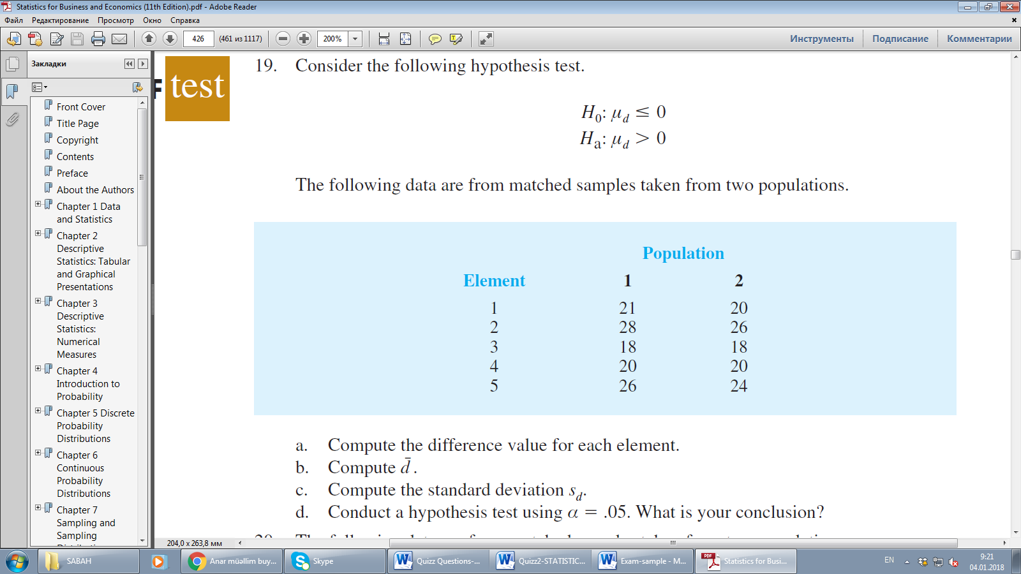

58) Explain simple random and systematic probability sampling methods with examples.
59)The results of a national survey showed that on average, adults sleep 6.9 hours per night. Suppose that the standard deviation is 1.2 hours. Use Chebyshev’s theorem to calculate the percentage of individuals who sleep between 4.5 and 9.3 hours.
- Five observations taken for two variables follow.
Compute and interpret the sample covariance.
Compute and interpret the sample correlation coefficient.

- A psychologist determined that the number of sessions required to obtain the trust of a new patient is either 1, 2, or 3. Let x be a random variable indicating the number of sessions required to gain the patient’s trust. The following probability function has been proposed.

f (x) =x/6
for x = 1, 2, or 3

a. Is this probability function valid? Explain.
b. What is the probability that it takes exactly 2 sessions to gain the patient’s trust?
c. What is the probability that it takes at least 2 sessions to gain the patient’s trust?

62) Phone calls arrive at the rate of 48 per hour at the reservation desk for Regional Airways.
a. Compute the probability of receiving three calls in a 5-minute interval of time.
b. Compute the probability of receiving exactly 10 calls in 15 minutes.

63) A simple random sample of 50 items from a population with σ =6 resulted in a sample mean of 32.
a. Provide a 90% confidence interval for the population mean.
64) A paper manufacturer has a production process that operates continuously throughout an entire production shift. The paper is expected to have a mean length of 11 inches, and the standard deviation of the length is 0.02 inch. At periodic intervals, a sample is selected to determine whether the mean paper length is still equal to 11 inches or whether something has gone wrong in the production process to change the length of the paper produced.You select arandom sample of 100 sheets, and the mean paper length is 10.998 inches. Construct a 99% confidence interval estimate for the population mean paper length.

- A doctor’s office staff studied the waiting times for patients who arrive at the office with a request for emergency service. The following data with waiting times in minutes were collected over a one-month period.
2 5 10 12 4 4 5 17 11 8 9 8 12 21 6 8 7 13 18 3

Use classes of 0–4, 5–9, and so on in the following:
a. Show the frequency distribution.
b. Show the relative frequency distribution.
c. Show the cumulative frequency distribution.

- Endowment income is a critical part of the annual budgets at colleges and universities. A study by the National Association of College and University Business Officers reported that the 435 colleges and universities surveyed held a total of $413 billion in endowments. The 10 wealthiest universities are shown below (The Wall Street Journal, January 27, 2009). Amounts are in billion of dollars.
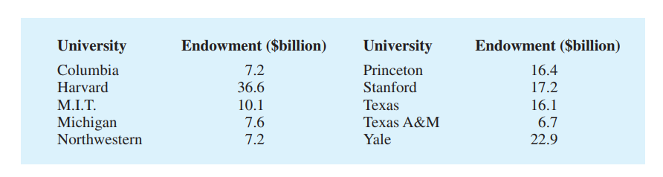
a. What is the median endowment?
b. What is the mode endowment?

- The following table provides a probability distribution for the random variable x.

a. Compute E(x), the expected value of x.
b. Compute the variance of x.
c. Compute σ, the standard deviation of x.

68) In San Francisco, 30% of workers take public transportation daily.
a. In a sample of 10 workers, what is the probability that exactly three workers take
public transportation daily?

69) Find the t value(s) for each of the following case.
a. Upper tail area of .025 with 12 degrees of freedom

70) Consider the following hypothesis test:
A sample of 75 is used and the population standard deviation is 10 and sample mean 23. State your conclusion for α= .01.
- Sales personnel for Skillings Distributors submit weekly reports listing the customer contacts made during the week. A sample of 65 weekly reports showed a sample mean of 19.5 customer contacts per week. The sample standard deviation was 5.2. Provide 95% confidence intervals for the population mean number of weekly customer contacts for the sales personnel.
- The mean number of hours of flying time for pilots at Continental Airlines is 49 hours per month (The Wall Street Journal, February 25, 2003). Assume that this mean was based on actual flying times for a sample of 100 Continental pilots and that the sample standard deviation was 8.5 hours. What is the 95% confidence interval estimate of the population mean flying time for the pilots?
- A simple random sample of 400 individuals provides 100 Yes responses.
a. What is the point estimate of the proportion of the population that would provide Yes responses?
b. Compute the 95% confidence interval for the population proportion.
74) You are the manager of a fast-food restaurant.You want to determine whether the waiting time to place an order has changed in the past month from its previous population mean value of 4.5 minutes. State the null and alternative hypotheses.
75)Consider the following hypothesis test:
A sample of 100 is used and the population standard deviation is 5 and sample mean 18. State your conclusion for α= .05.

